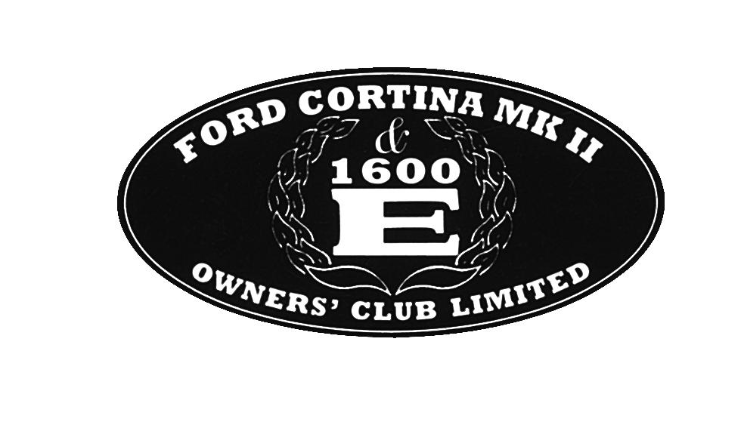THE FORD CORTINA MK11&1600E

OWNERS’CLUB LIMITED

APPLICATION FOR COMPANY MEMBERSHIP(UK)
Membership of the Club (“Company”) is open to anyone who owns—or has a genuine interest in– the Ford Cortina Mk.11.
All Members are full Members and therefore have full voting rights at the A.G.M. and elsewhere.
Any Member may hold a position on the Company’s Board but must be voted onto it by the assembled Membership at the A.G.M., following prior notice having been given to the Membership in accordance with the Memorandum and Articles of Association of the Company.
All benefits of Club Membership are available to fully paid-up Members except those residing in North America and Canada where the sale of spare parts is prohibited; a specially reduced joining fee is therefore appropriate in such cases.

Details given below are held on computer for Company use only. If you object, please inform the Membership Secretary.

All applicants for Membership please complete the following, using CAPITAL LETTERS when writing your name and address.

SURNAME ______________________________________ FIRST NAME __________________________________________

ADDRESS _____________________________________________________________________________________________

_______________________________________________________________________________________________________

COUNTY ______________________________________ POST CODE ____________________________________________

TELEPHONE NUMBER (Incl. Std. Code) ____________________________________________________________________

EMAIL ADDRESS _______________________________________________________________________________________

On occasions, members may wish to contact others in their area. We are unable to pass on details unless you give us permission to do so, due to Data Protection laws.

For this reason, we request you to sign one of the following statements. Please do not leave both blank.

I have no objection to my telephone number being given to another member. Signed: _______________________

I do not wish my telephone number to be given to another member. Signed: _______________________

I apply for membership of THE FORD CORTINA MK11 &1600E OWNERS’ CLUB LIMITED.
I enclose a *Cheque/Postal Order/Bank Draft (*delete as appropriate) for the sum of £ _____________ payable to

THE FORD CORTINA MK11 & 1600E OWNERS’ CLUB LIMITED.
(We regret that we are only able to accept cheques drawn to U.K. banks.)
A credit card facility is also available for payment. To use this, contact Paul Warwick on 07947 649495 with your details.

Signed ________________________________________________ Dated _______________________________

Return to: Paul Warwick
Membership will run from the period.
33 Hartleyburn,
Wilnecote,
Tamworth.
B77 4BL

