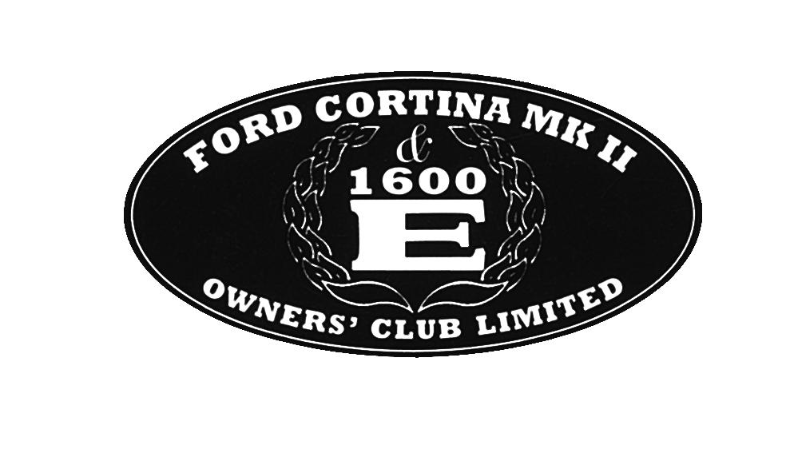
Registered Office

Registered Office: 304 Braunstone Lane, Leicester LE3 3AT
Registered No: 4799639

APPLICATION TO BECOME A MEMBER OF
THE FORD CORTINA MK 11 & 1600E OWNERS’ CLUB LIMITED
(COMPANY NUMBER 4799639)
(“the Company”)

I hereby apply to become a member of the Company.

If my application is accepted I hereby agree to:-

- be bound by the Memorandum and Articles of Association of the Company (as amended from time to time);

- comply with the obligations to contribute a sum not exceeding £1.00 to the assets of the Company in the event of the Company being wound up in accordance with clause 7 of the Memorandum of Association of the Company;

- promptly inform the Company Secretary of any change in address or other changes in my particulars.

I wish that you place my name on the Register of Members of the Company.

Name (Please PRINT)__________________________________________________

Signature__________________________________________________________

Address__________________________________________________________

__________________________________________________________________

____________________________________________________________________

Date_______________________________

Complete and return to the Membership Secretary at
Email: paw_109@hotmail.com
33 Hartleyburn, Wilnecote, Tamworth. B77 4BL

